🧩 SOC Home Lab Architecture (IOC & Threat Intel Workflow)
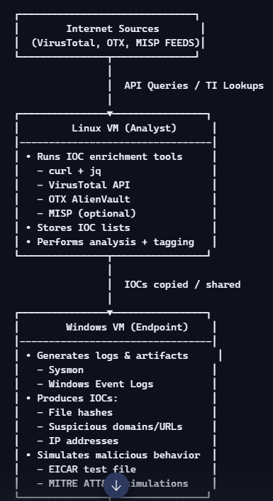
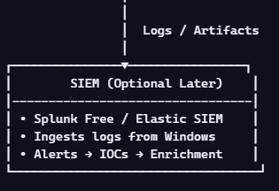

Windows VM = Endpoint / Log Source
This is where you:
- Generate file hashes
- Simulate suspicious activity
- Collect domains, IPs, URLs
- Trigger Sysmon logs
- Produce artifacts that become IOCs
Think of it as the “victim machine” in a SOC.

Linux VM = Analyst Workstation / Threat Intel Hub
This is where you:
- Query VirusTotal
- Query OTX
- Run enrichment scripts
- Store IOC lists
- Install MISP (optional)
- Document findings
This is your “SOC analyst workstation.”

Internet = Threat Intelligence Providers
Your Linux VM reaches out to:
- VirusTotal
- OTX AlienVault
- Hybrid Analysis
- Any.Run
- MISP feeds
This is how you enrich IOCs.

SIEM (Optional Later)
Once you’re comfortable with IOC enrichment, you can:
- Forward Windows logs to Splunk
- Detect IOCs using lookup tables
- Build correlation rules
But you don’t need SIEM to start IOC enrichment.
If you want, I can now walk you through:
Next Step: Step-by-Step IOC Enrichment Playbook
or
Next Step: Automating VirusTotal lookups with a Python script
Just tell me which direction you want to go.

Step 1 = defining the roles of your machines so you know where each task happens.
- Your Windows VM acts like the “endpoint” in a real SOC. This is where you:
  - generate logs
  - hash files
  - simulate suspicious activity
  - collect IOCs
- Your Linux VM acts like the “analyst workstation / TI platform.” This is where you:
  - run VirusTotal API queries
  - run enrichment scripts
  - store IOCs
  - install MISP (optional)
  - perform analysis

Step 2: Collect some basic IOCs
We’ll collect three types of IOCs:
- File hashes
- Domains / URLs
- IP addresses
Then we’ll organize them into a simple list you can later enrich.

✅ Step 2.1 – Create or identify files to hash
You don’t need real malware. You just need any files to practice with.
On your Windows VM:
- Create a test folder, e.g.: C:\IOC_Lab\Samples
- Put a few files in there:
  - Download a couple of installers (e.g. VS Code, 7-Zip)
  - Create a text file: notes.txt
  - Create a PowerShell script file: test.ps1 (can be empty)
- You should now have something like:
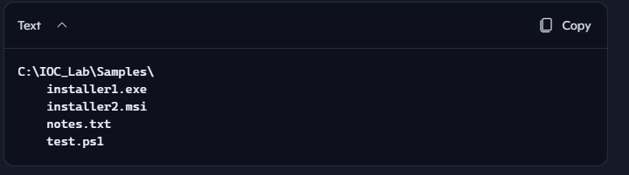
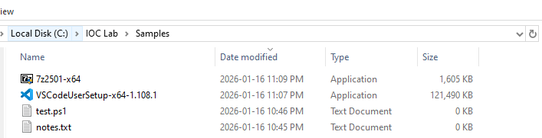

✅ Step 2.2 – Generate file hashes (SHA256)
Now we’ll turn those files into hash IOCs.
- Open PowerShell as Administrator
- Run:

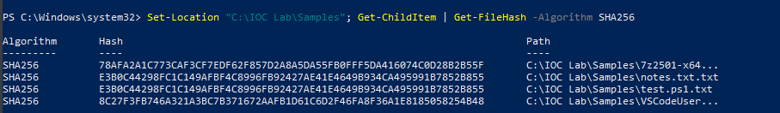
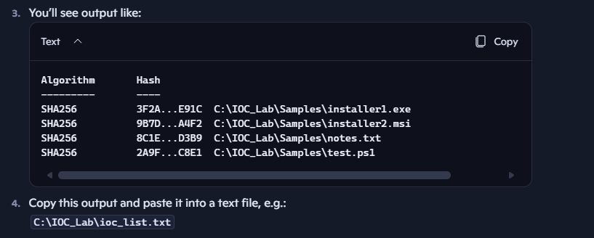

✅ Step 2.3 – Collect domains / URLs
Now let’s gather some domains and URLs to treat as IOCs.
You can use:
- Real sites (safe)
- Fake phishing-style domains (for practice)
Examples:
- login-secure-microsoft.com (fake)
- secure-paypal-verification.net (fake)
- accounts.google.com (real)
- update-dropbox-storage.com (fake)
Create a section in your ioc_list.txt file like:
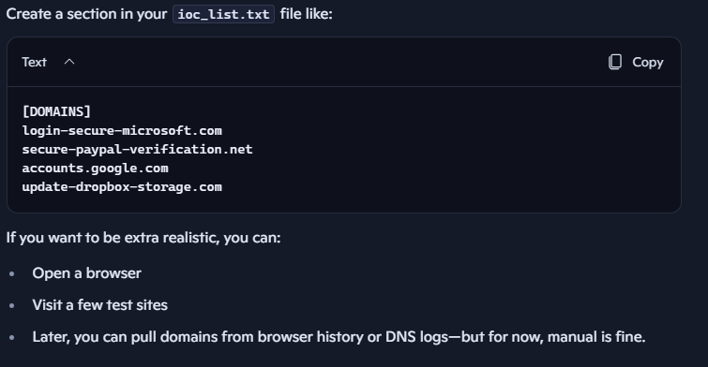

✅ Step 2.4 – Collect IP addresses
You can use:
- Public IPs (e.g. DNS servers)
- Random IPs for practice
- IPs from ping commands
In PowerShell, run:
Ping 8.8.8.8
Ping 1.1.1.1
Then add these to your IOC list:
[IPS]
8.8.8.8
1.1.1.1
203.0.113.10
198.51.100.25
(The last two are example IPs from documentation ranges—safe to use as fake IOCs.)

✅ Step 2.5 – Organize everything into a single IOC file
Now your C:\IOC_Lab\ioc_list.txt might look like this:
[HASHES]
3F2A...E91C C:\IOC_Lab\Samples\installer1.exe
9B7D...A4F2 C:\IOC_Lab\Samples\installer2.msi
8C1E...D3B9 C:\IOC_Lab\Samples\notes.txt
2A9F...C8E1 C:\IOC_Lab\Samples\test.ps1

[DOMAINS]
login-secure-microsoft.com
secure-paypal-verification.net
accounts.google.com
update-dropbox-storage.com

[IPS]
8.8.8.8
1.1.1.1
203.0.113.10
198.51.100.25
This is now your IOC seed list.

✅ Step 2.6 – Move IOC list to your Linux VM
You’ll need this IOC list on Linux for enrichment.
Options:
- Easiest: Copy/paste contents into a new file on Linux
- Or use SCP / shared folder if you’ve set that up
On Linux, create:
mkdir -p ~/ioc_lab
nano ~/ioc_lab/ioc_list.txt
Paste the content from Windows into this file and save.

Step 3: Set up basic TI tooling on Linux

✅ Step 3.1 – Update your Linux VM
Open a terminal on your Linux VM and run:
sudo apt update && sudo apt upgrade -y
This makes sure you’ve got the latest packages and avoids weird dependency issues later.

✅ Step 3.2 – Install core CLI tools
sudo apt install -y curl jq python3 python3-pip git
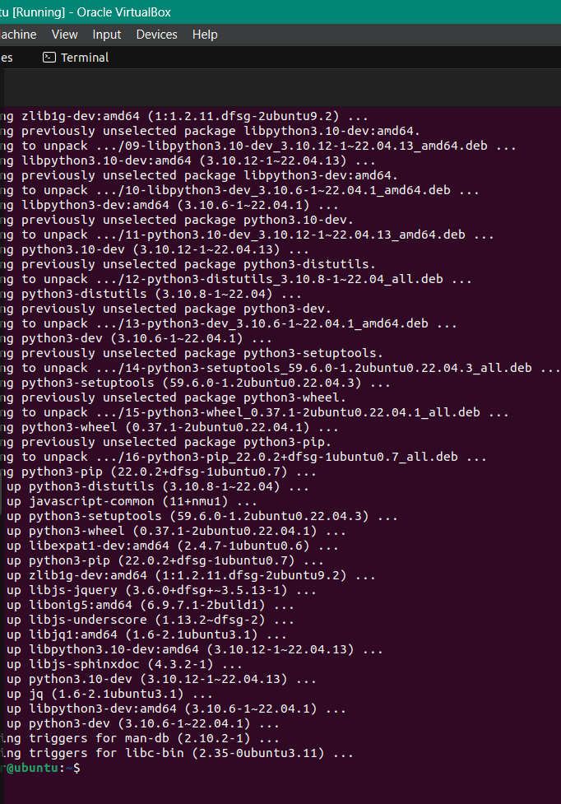
• curl: for making HTTP requests (e.g., to VirusTotal API)
• jq: for parsing JSON responses
• python3 / pip: for scripting and using VT libraries
• git: for cloning tools later if needed

✅ Step 3.3 – Create a working directory for your IOC lab
Keep things organized from day one.
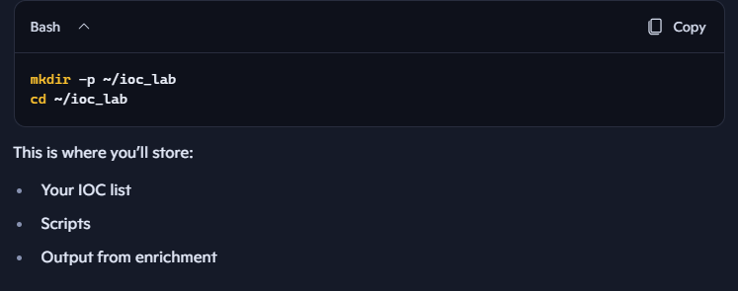

✅ Step 3.4 – Install the VirusTotal Python library (optional but useful)
You can interact with VirusTotal via raw curl, but a Python library makes life easier later.
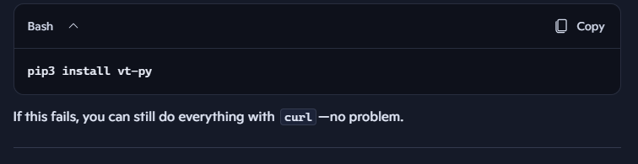
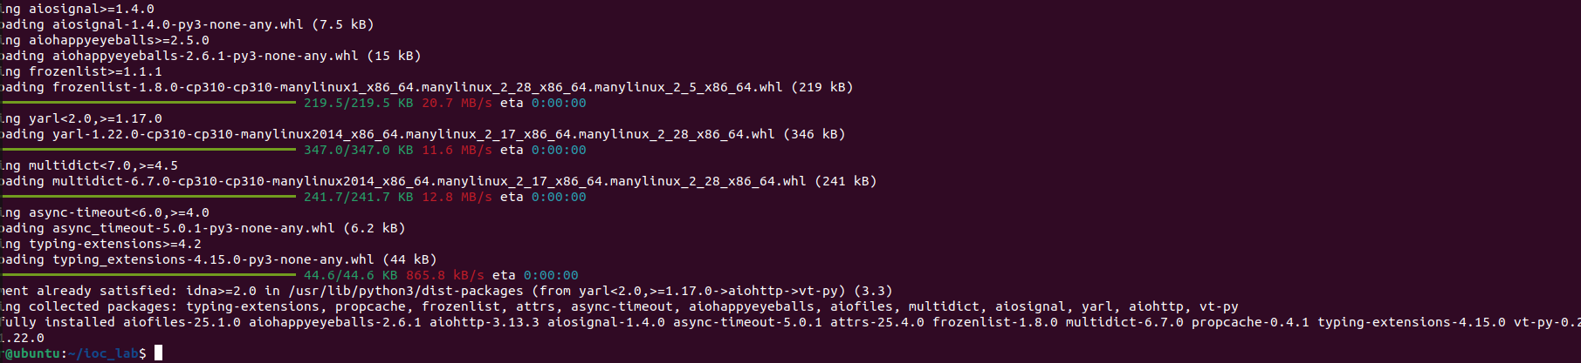

✅ Step 3.5 – Store your VirusTotal API key securely
You’ll need a free VirusTotal account for this (if you haven’t created one yet, do that in a browser, grab your API key from your profile).
Virus total credentials: bkanuko85@gmail.com, Myraj11$
API key - 869638764e1a3584892c80f0d40ac73605019ced40306557045b1e816e0101bd

Once you have your key:
echo "YOUR_API_KEY_HERE" > ~/.vt_api_key
chmod 600 ~/.vt_api_key
This:
- Saves your key in a hidden file
- Restricts permissions so only your user can read it
You can test that it’s readable:
cat ~/.vt_api_key
You should see your key printed.
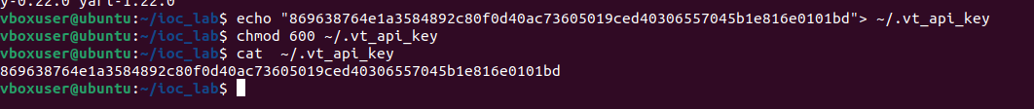

✅ Step 3.6 – Create a simple test script for VT hash lookup (using curl)
Let’s make sure everything works before we automate anything.
- In your ~/ioc_lab directory:
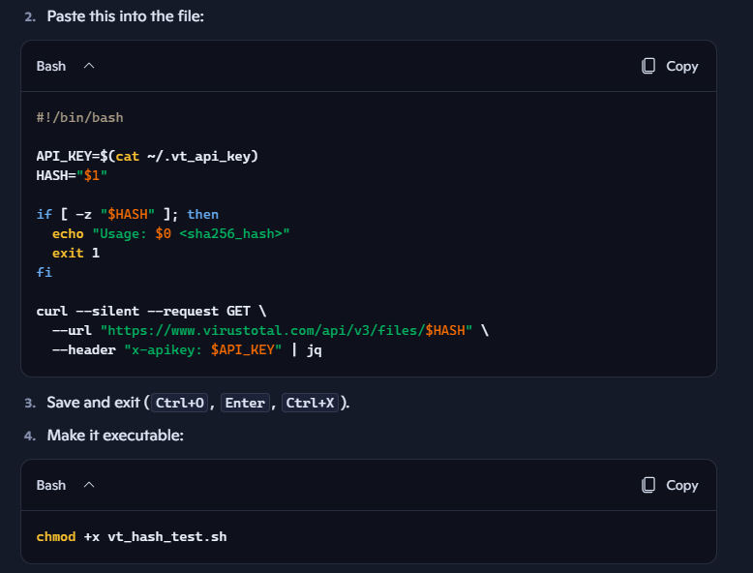
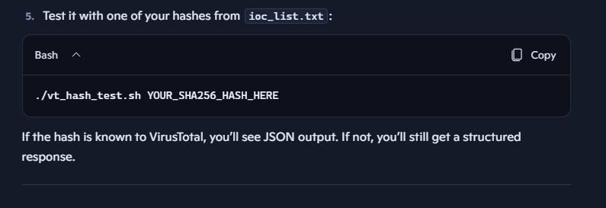
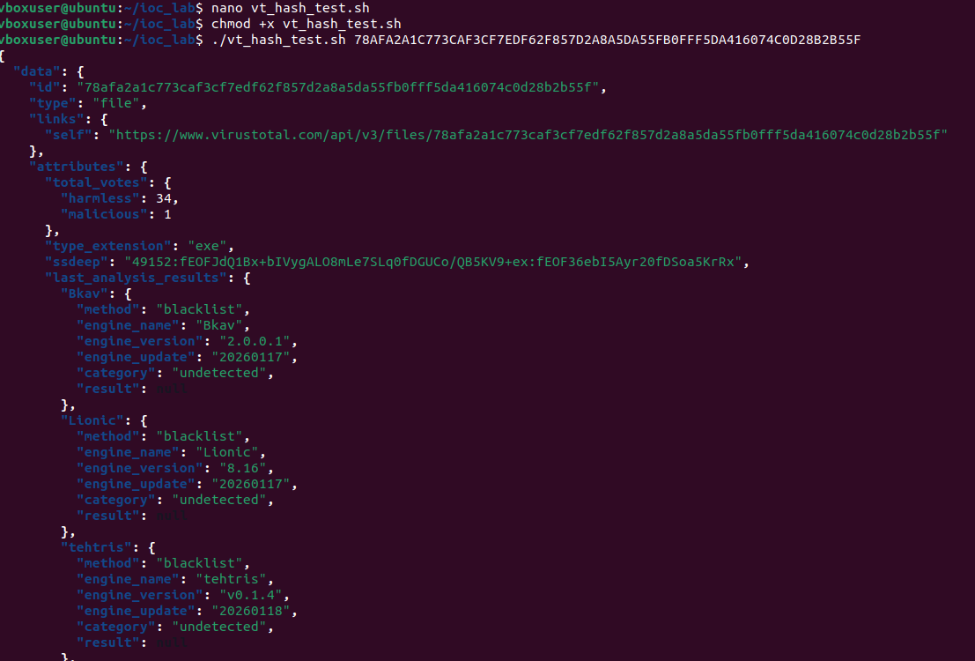

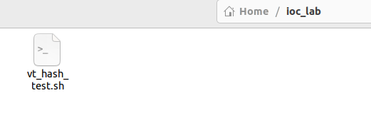
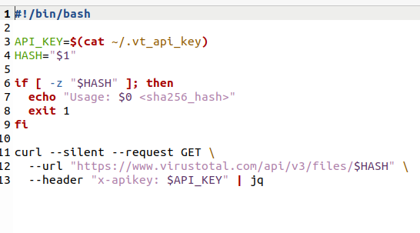

✅ Step 3.7 – Create a similar script for domain lookup
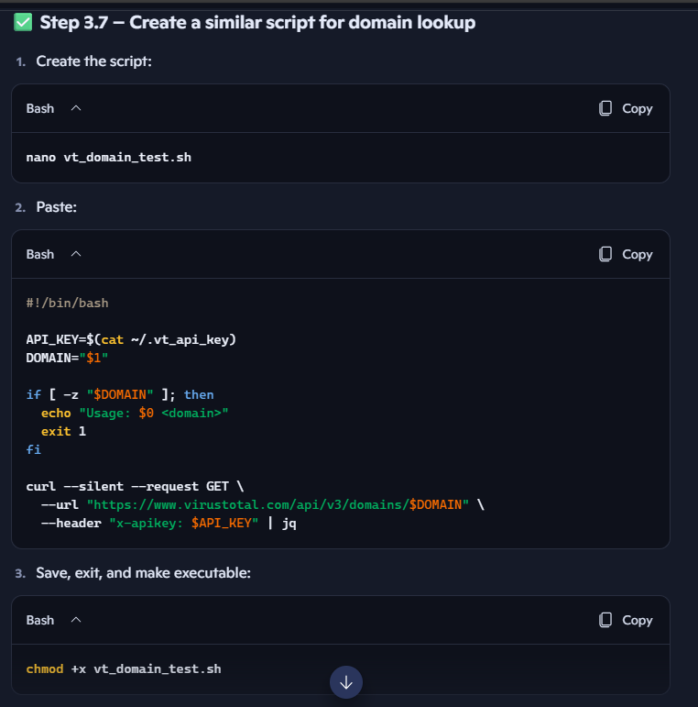
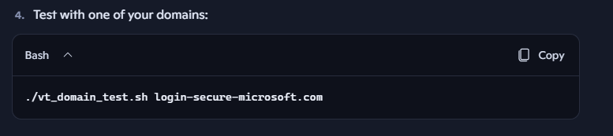
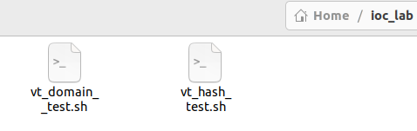
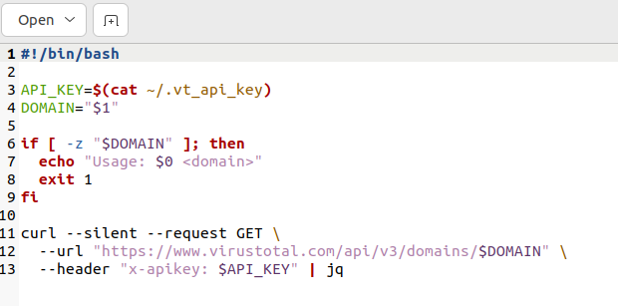
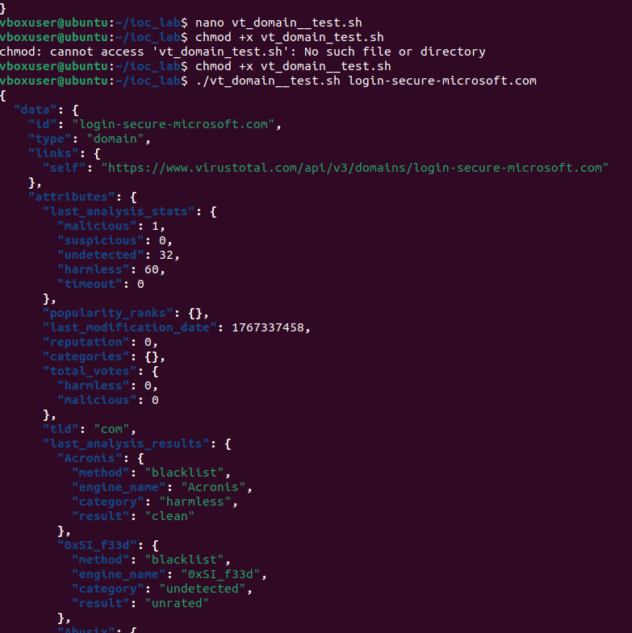

✅ Step 3.8 – (Optional) Create a script for IP lookup
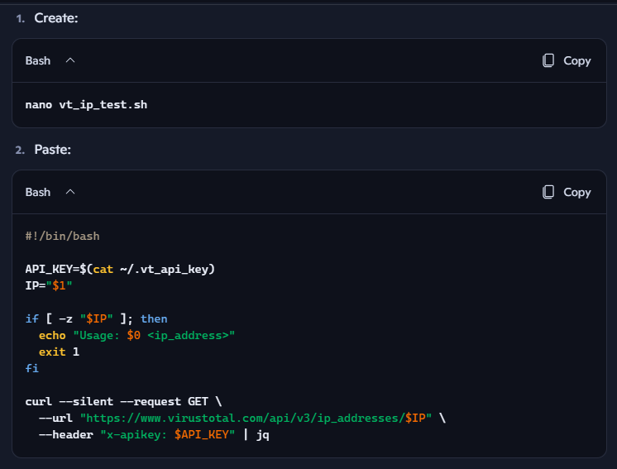
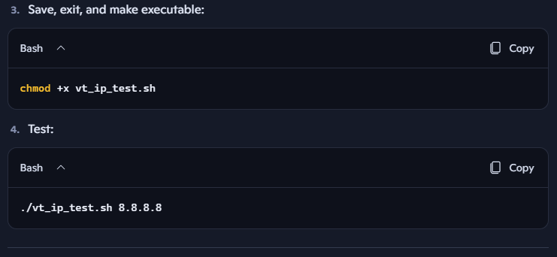
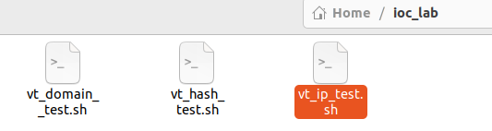
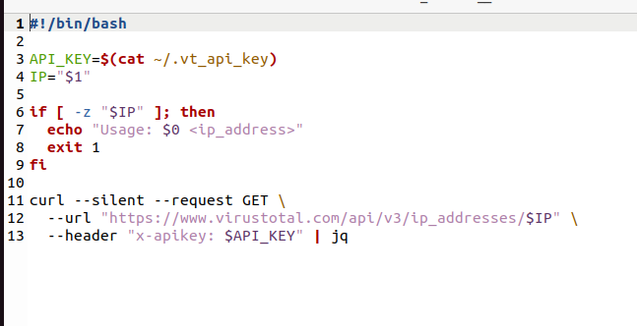
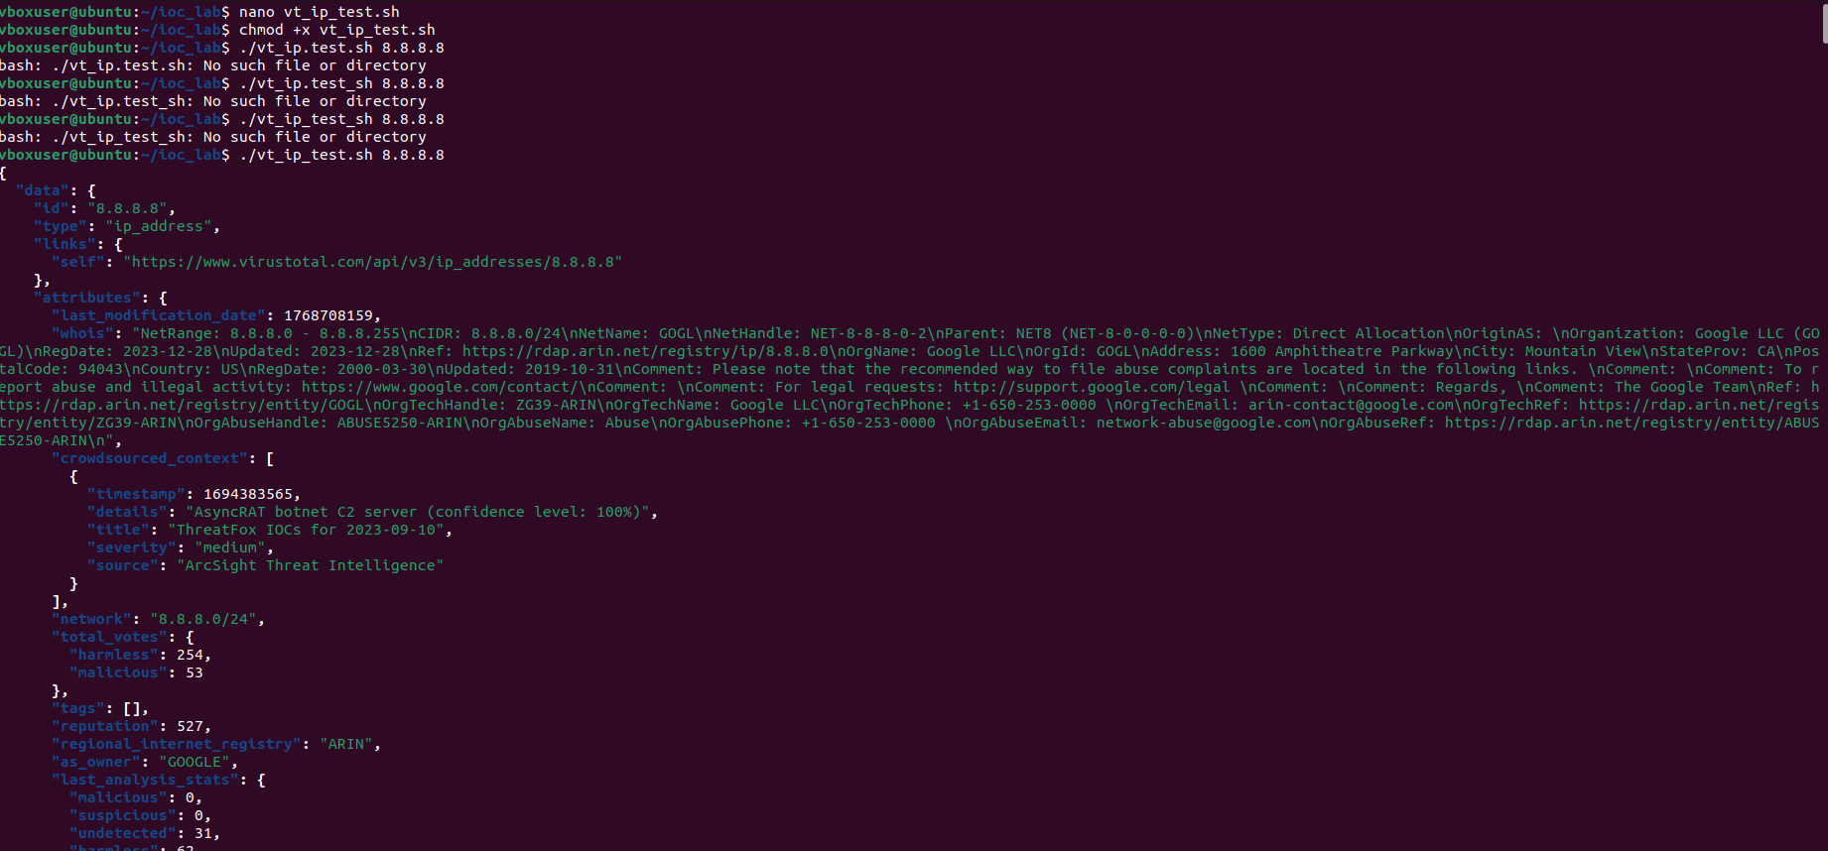

✅ Step 3.9 – Quick sanity check: your TI tooling is ready if…
You can say Step 3 is fully done when:
- curl and jq are installed and working
- Your ~/.vt_api_key file exists and is readable
- You can run:
  - ./vt_hash_test.sh <hash>
  - ./vt_domain_test.sh <domain>
  - ./vt_ip_test.sh <ip>
- And you see JSON responses from VirusTotal
At that point, your Linux VM is officially a basic TI workstation.

Step 4: Get a free VirusTotal API key
- Go to https://www.virustotal.com
- Create a free account
- Go to your profile → find your API key
- Store it in a file on Linux:
echo "YOUR_API_KEY_HERE" > ~/.vt_api_key
chmod 600 ~/.vt_api_key

Step 5: Test IOC enrichment with VirusTotal (hash)
On Linux, create a small script to query a hash:
API_KEY=$(cat ~/.vt_api_key)
HASH="<your_sha256_here>"
curl --request GET \
--url "https://www.virustotal.com/api/v3/files/$HASH" \
--header "x-apikey: $API_KEY" | jq
Look for:
- last_analysis_stats
- malicious / suspicious counts
- Any tags or threat labels

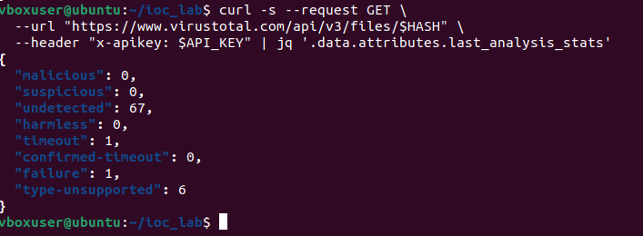
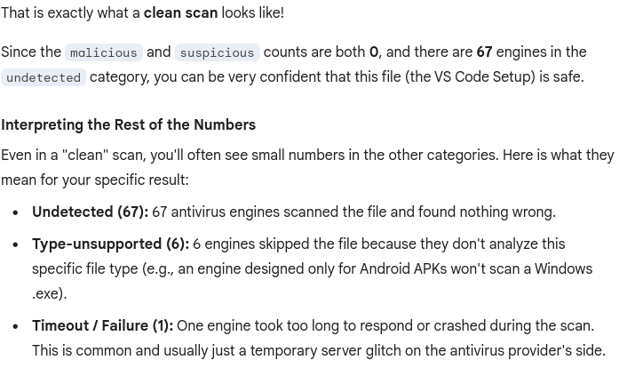
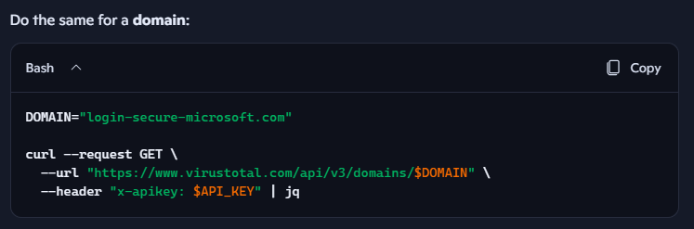
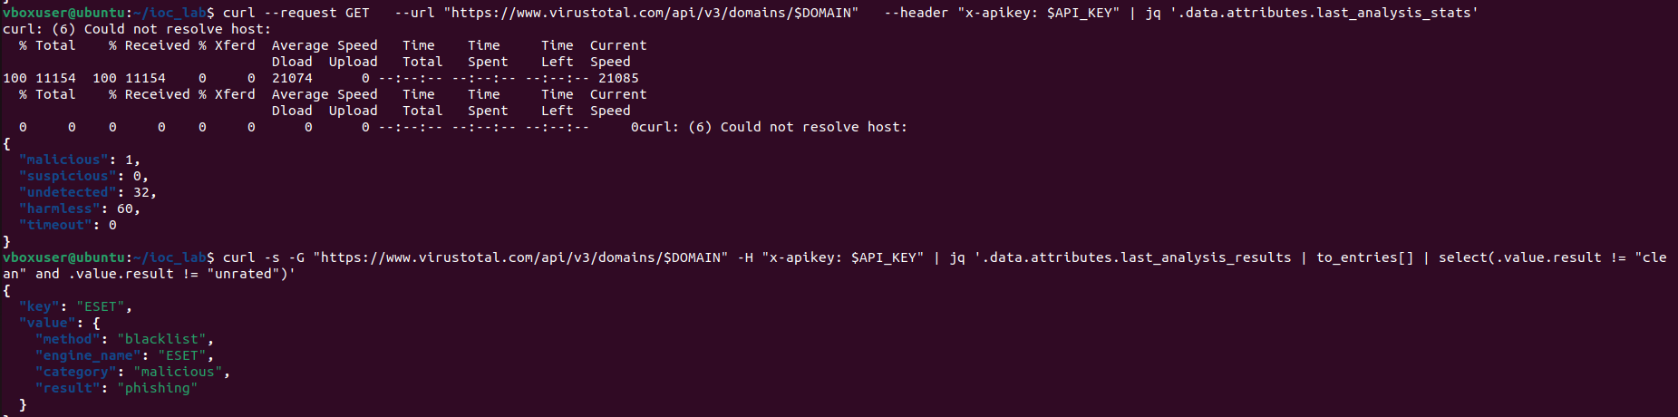
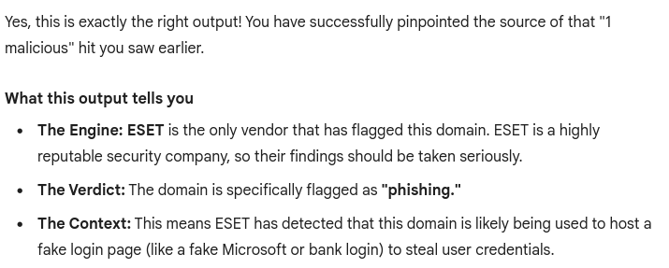
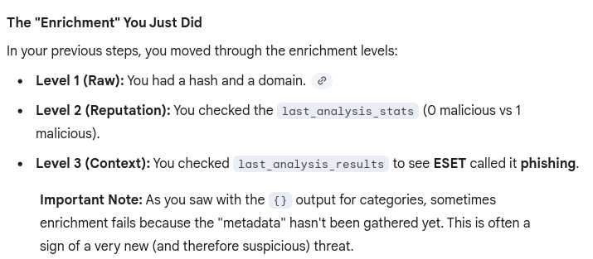

Step 6: Organize your IOC enrichment output
Create a simple structure for your findings, e.g. in a Markdown file or notes:
For each IOC:
- Type: hash / domain / IP
- Value:
- VT verdict: malicious / suspicious / harmless
- Vendors flagging it:
- Categories / tags:
- Any related URLs / samples:
This is exactly how SOC analysts document enrichment.

Step 7: Add OTX (AlienVault) lookups
- Go to https://otx.alienvault.com
- Create a free account
- Use the web UI first:
  - Search your domain, IP, or hash
  - Note if it appears in any pulses (threat intel collections)
Later, you can use the API, but for now, the UI is enough to understand:
- Whether your IOC is known
- What campaigns or malware families it’s tied to

Step 8: Tie this back to a SOC workflow
To make this “SOC-real” in your mind and on your résumé, think of the flow like this:
- Alert fires (in a real SOC, from SIEM/EDR)
- You extract:
  - Hashes
  - Domains
  - IPs
- You enrich them using:
  - VirusTotal
  - OTX
  - (Optionally) MISP
- You decide:
  - Is this benign, suspicious, or malicious?
  - Does it match known campaigns?
- You document:
  - IOC
  - Enrichment results
  - Recommended action (block, monitor, ignore)
That’s exactly what you’re simulating here.

